# Chapter 6- Other project issues

**6.1 Limitations**

Some of the features that’s need to be implemented but cannot be completed are refer to be the limitation of the project and there are some of the things that I cannot complete and they are listed below:

* We were unable to perform some of the unit testing of the program
* We would have performed the Agile methodology but unable due some insufficient knowledge
* Some of the additional features such as tracking campaign with dynamic code was unable to implement

**6.2 Futures works**

With the limitation period I was unable to add some features and function to the system which I had mentioned in proposal. And those incomplete features would be implemented in future works.

The listed below incomplete features would be completed in future work and they are:

* Dynamic code to track the campaign management
* Reviewing and comments
* Login system using QR code

**6.3 Risk management**

Project risk management is the process of identifying, analyzing and then responding to any risk that arises over the life cycle of a project to help the project remain on track and meet its goal. Risk management isn’t reactive only; it should be part of the planning process to figure out risk that might happen in the project and how to control that risk if it in fact occurs.

Risk faced during the project development are:

* Incomplete knowledge of the Laravel framework
* Choosing the right tool for the designing of different aspects
* Time management
* Internal testing of the program or software that is with Unit Testing
* Overtaking server failure
* Setting up site not be attacked by DOS or DDOS attack

Some of the risk that might occur are listed below with impact and solution to it:

|  |  |
| --- | --- |
| **Likelihood (L)** | **Value** |
| Low | 1 |
| Medium | 2 |
| High | 3 |

|  |  |
| --- | --- |
| **Consequences (C)** | **Value** |
| Very Low | 1 |
| Low | 2 |
| Medium | 3 |
| High | 4 |
| Very High | 5 |

|  |  |  |  |  |  |
| --- | --- | --- | --- | --- | --- |
| **SN** | **Risks** | **Likelihood** | **Consequence** | **Impact** | **Actions** |
| 1 | Natural disaster | 1 | 5 | 5[1*5] | Backup plan |
| 2 | Hardware or software crash | 2 | 3 | 6[2*3] | Maintenance |
| 3 | System may get infected with virus | 2 | 4 | 8[2*4] | Antivirus Software |
| 4 | Theft | 3 | 2 | 6[3*2] | Backup |
| 5 | Insufficient time | 3 | 3 | 9[3*3] | Must keep milestone on mind |
| 6 | Requirements may not be found easily | 3 | 1 | 3[3*1] | Should take an example of similar type of web application |

**Gantt Chart**

Grant chart in which a series of horizontal lines shows the amount of work done or production completed in certain periods of time in relation to the amount planned for those periods.

**6.4 Configuration Management**

Configuration management can be described as identification process, individual configuration object, functional capability documentation, and interdependence monitoring. Simply put, configuration management is a method of demonstrating how the files and folder are interrelated, and what will happen when any changes are made. It is file and folder management.

**6.5 User Manual**

Since releasing this software onto the market, the program is new and consumer cannot know how to properly use the application. In order to ensure that user find its easy to use I must include a user manual page which instruct user on how to create account and login as well as how to generate code and scan the available code.

Every steps to follow while using this system is defined below with all label in figures, following those step helps the user interacting easier to system:

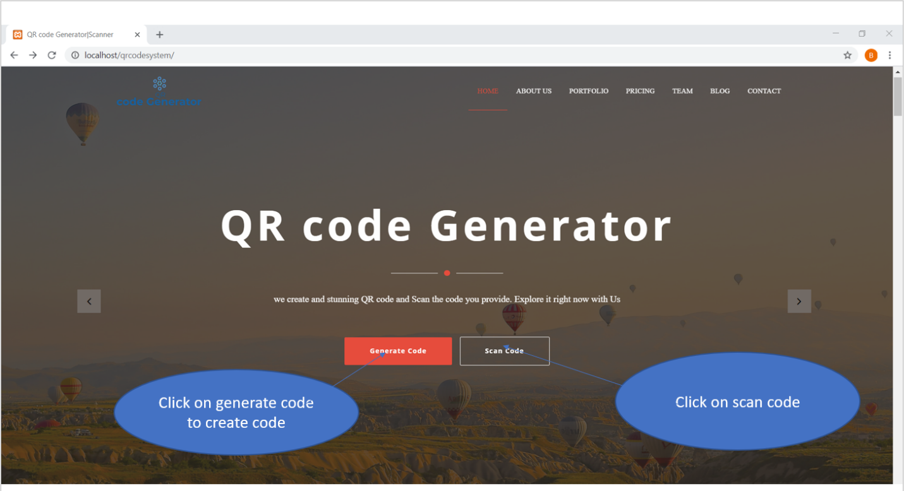

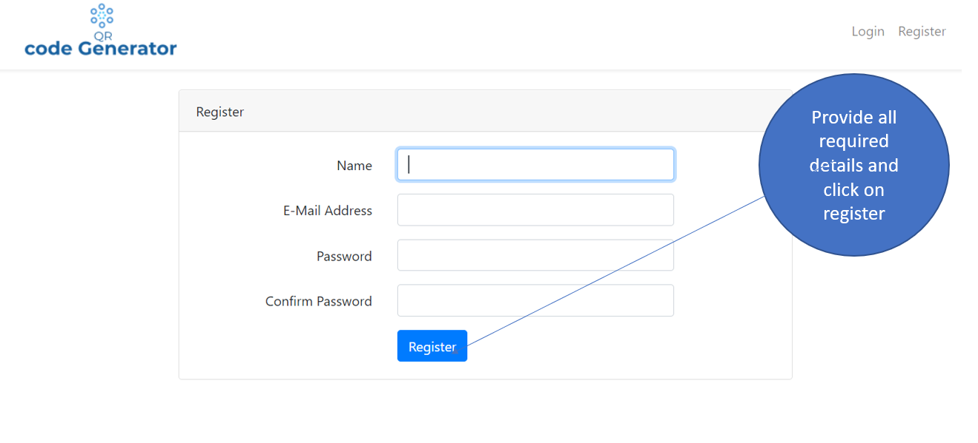

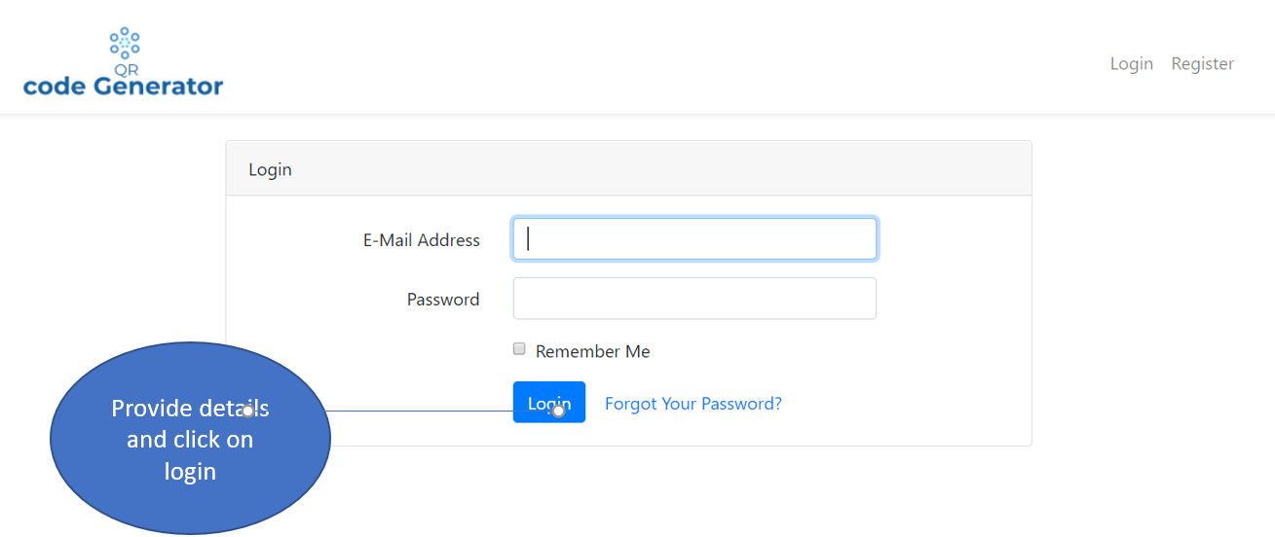

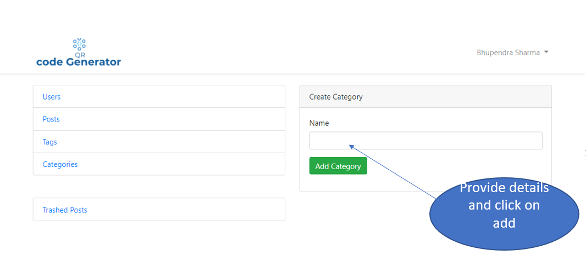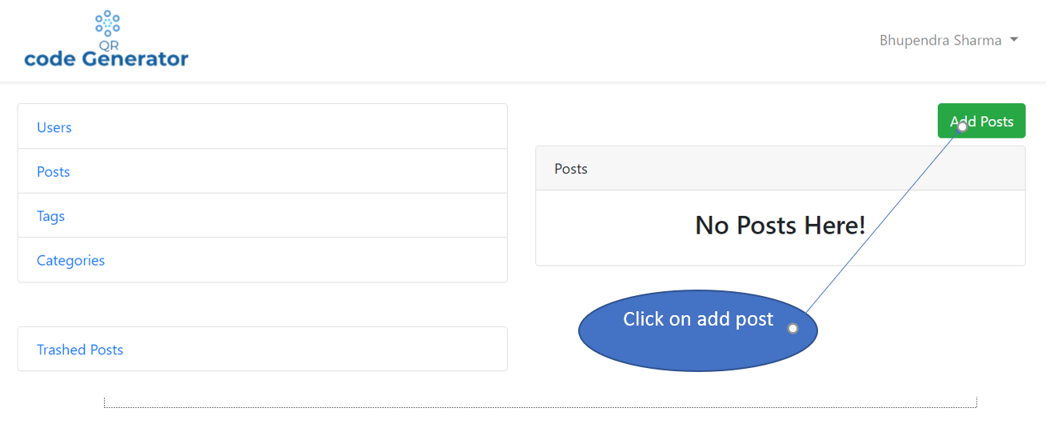

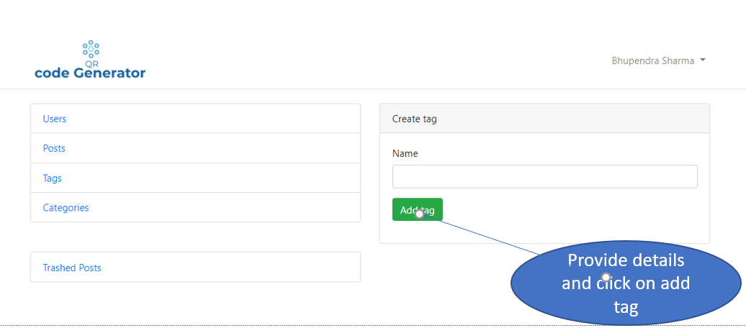

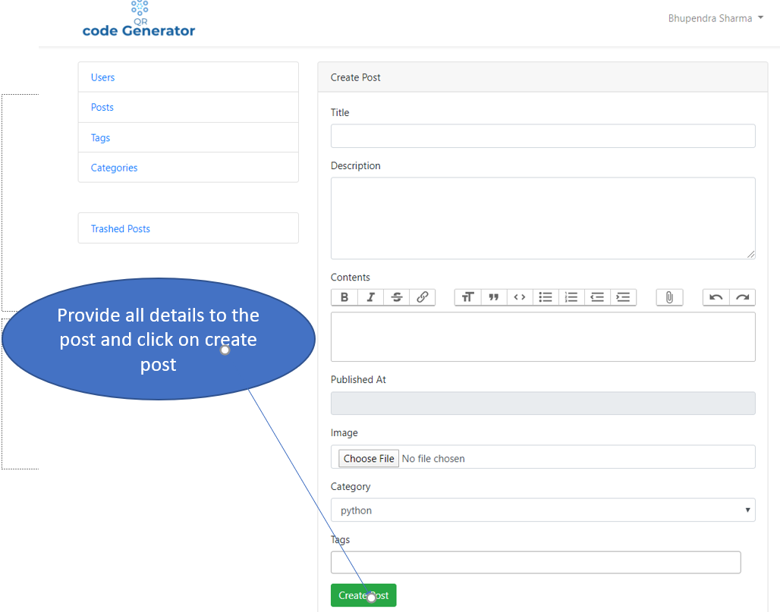

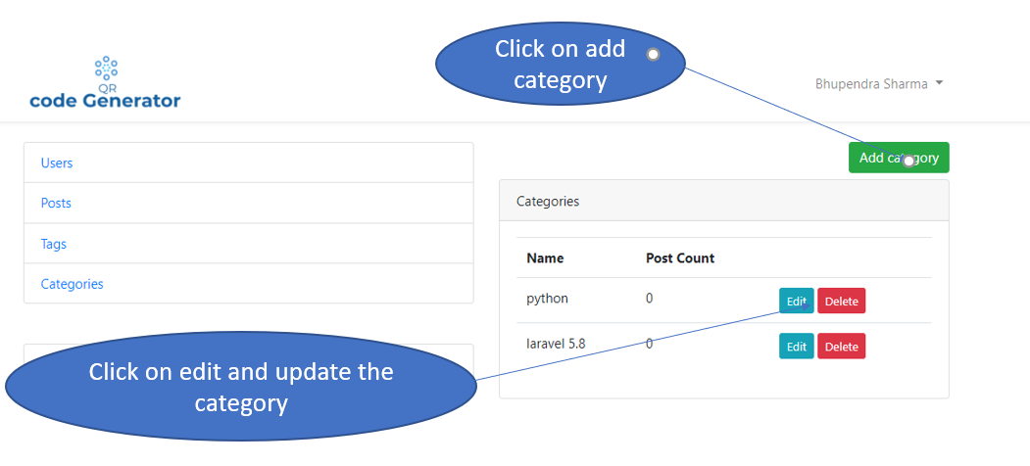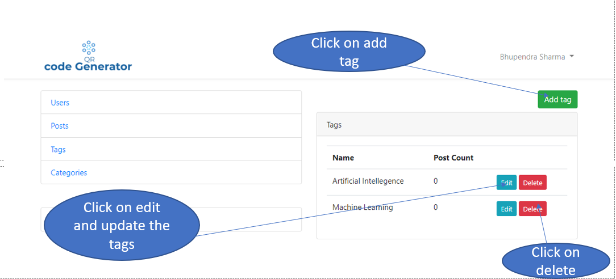

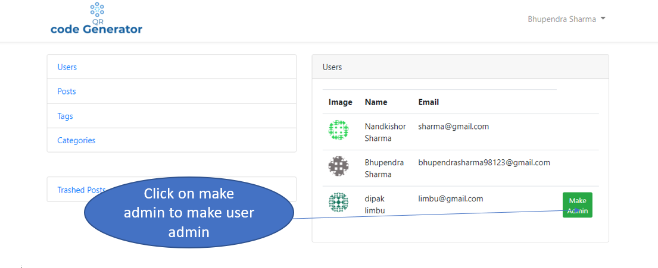

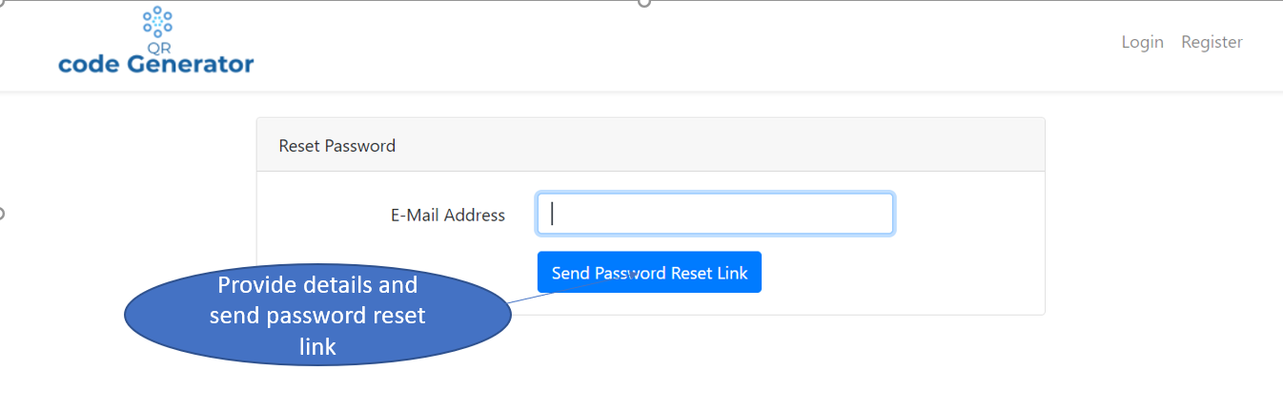

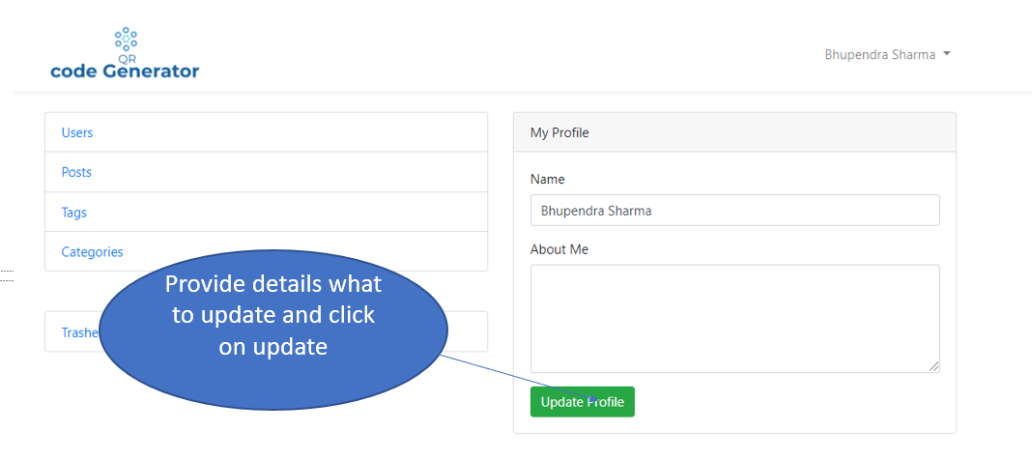

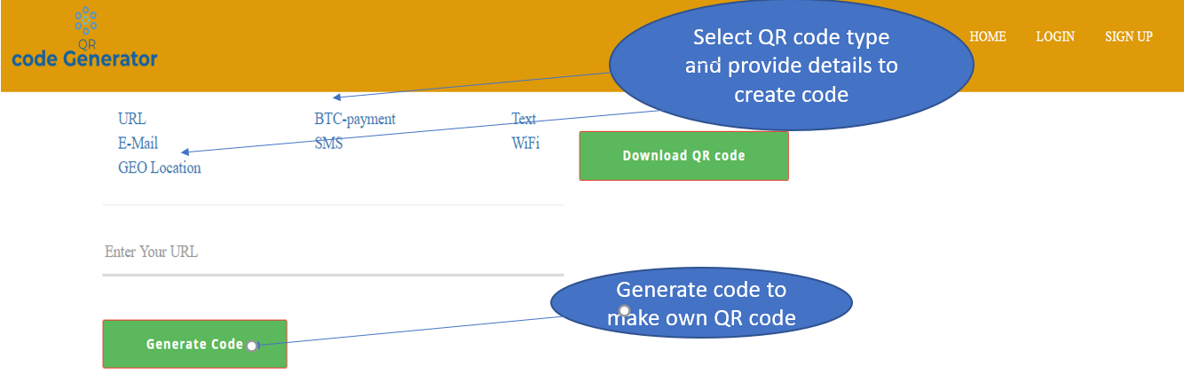

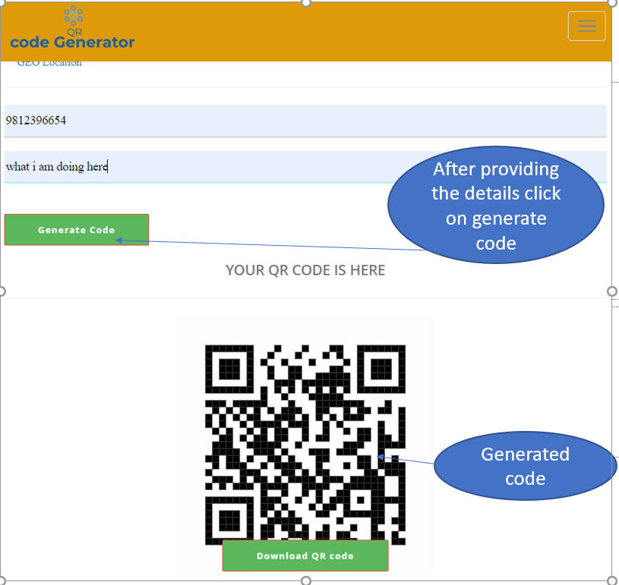

**Chapter 7- Conclusion**

After all the development process has been completed, QR code generator is ready to launch after all the functions are tested. This system is an efficient, simple and user friendly, with developed system user can easily generate code form the place where they are. The system design is responsive and admin is provided with the CMS authority where he can manage all the post and related item with the database and site settings.

All users should register as regular user and their function can only be modified by admin. Admin and customer have varied authority. Users may have their profile updated. I have completed nearly all the pieces of this project's documentation as well as the section of implementation.